5.1 Graph Traversals - BFS & DFS -Breadth First Search and Depth First Search

They are graph traversals methods.

We should know these things: 1-Visiting a vertex=going on a particular vertex

2-exploration of vortex= If I am a particular object,I visit adjacent vertices.

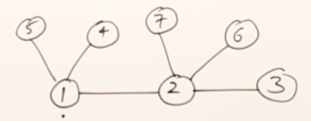

**Breadth First Search**: 1-you can pick any vertex you want. I visit vertex 1 then I visit adjacent vertexes 5 4 and 2 I can visit them in any order I want Then I visit vertex 2 and its adjacent vertexes In any order you can take.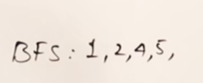

2-I should select next vertex for exploration. We have visited these vertexes 

Then I will explore 2 Who are adjacents of two ? 7 and 6 and 3 In any order you can take them*

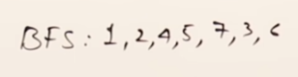 all vertices are visited. And there is no vertex for exploration. This is Breadth for Search.

All verses are visited and there is no remaining for exploration. This is Breadth First Search

**Depth First Search:**  I start 1 and I start exploration. YOU DO NOT EXPLORING ADJACENTS OF 1 YOU GO TO NEXT VERTEX so I go vertex 2 but again I do not visit its adjacent vertexes I go to 3 then I see that there is no element to visit in Three so I come back to 2 and visit 7 and 6 . then we come to 1 and visit 5 and 4



(While visiting 2 for ex we visit 7 and 6 we also check those numbers have adjacent vertexes)

In Breadth first search; we explore vertex and we go to the next vertex

In depth first search ;once we extracted exploring once you visited a new vertex we will suspend this vertex and start its exploration.

One more example; 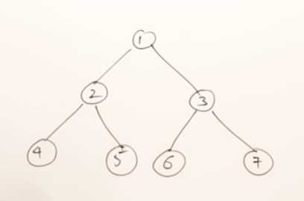

Tree are also graph****

**Breadh First Search**= 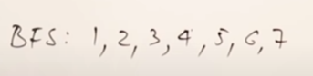

**In binary tree Breath first search is like a level order** (ornegin 1 sayisi 0’inci rootta 2 ve 3 1’inci level’da ve digerleri 4 ve 5 6 ve 7 gibi 3’uncu levelda buna gore Breath for search yapabilirsin.**

**Depth First Search:** 1-explore 1 2- We have Two,stop explore 1 and explore 2 we got 4 3- stop exploring 2 and continue to explore 4 - 4 has no childs and come to 5 and nothing is remanin

5- go back to one and go to 3 then 6 and 7 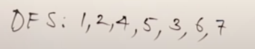

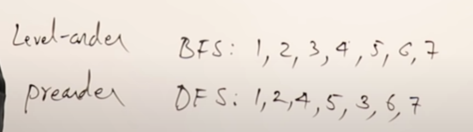

Breadth for search is level order and depth for search is pre order.

New example: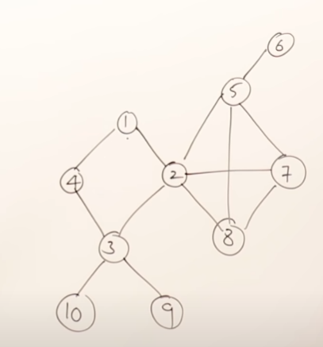

I’ve taken data structure Queue 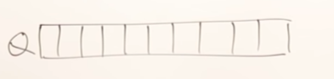

Breadth First Search : 

**For initial step you randomly choose a number**.

You can select any vertex you want

For repeating step:Start 1 Adjacent to 1 are 4 and 2

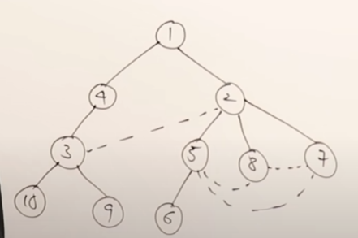 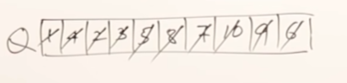

This tree is breath for search spanning tree.

What we’ve learned

1-You can start any vertex of you want in Breadth First Search.

2-When you visit vertex you visit for example 1 here you can visit 2 an 4 any order you want

3-When you are selecting vertex,you have to visit all adjacent vertices then u should go next vertex

4-u can select next vertex in Q only

**Let’s write few more Breadth First Searches*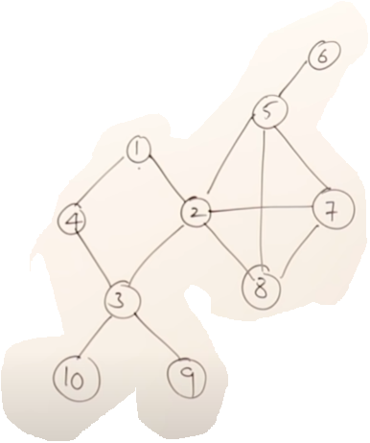**

I visit 1 first then 2 and 4

Then I visit 2’s elements 8,5,7,3…

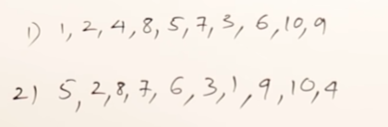 As we see here they are 2 results because we can start any vertex we want.

**Depth For Search:** 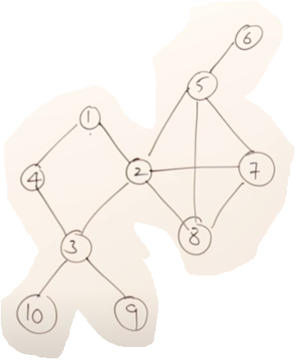

I can start the traversal from any vertex I want to start vertex 1 this is INITIAL STEP what is repeating step what I have to do every time.The rule in depth first searches once u visit one vertex still one is remaining leave that we will see it afterwards first exploring 4

